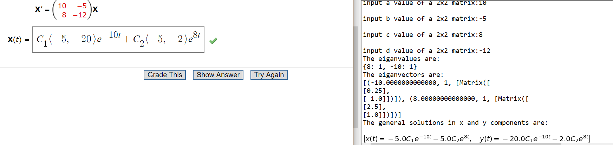

Webassign problem

Matrix values from Webassign problem

Correct answer in expanded form